First,we run main.py to set up the movie recommendation system,then double click recommendation.html to enter movie recommendation system page.In this page,we can input the person’s id and click the search button.Then,the search results,movie pictures and movie links are showed below.Click the links,a related page will be showed.

Searching results:

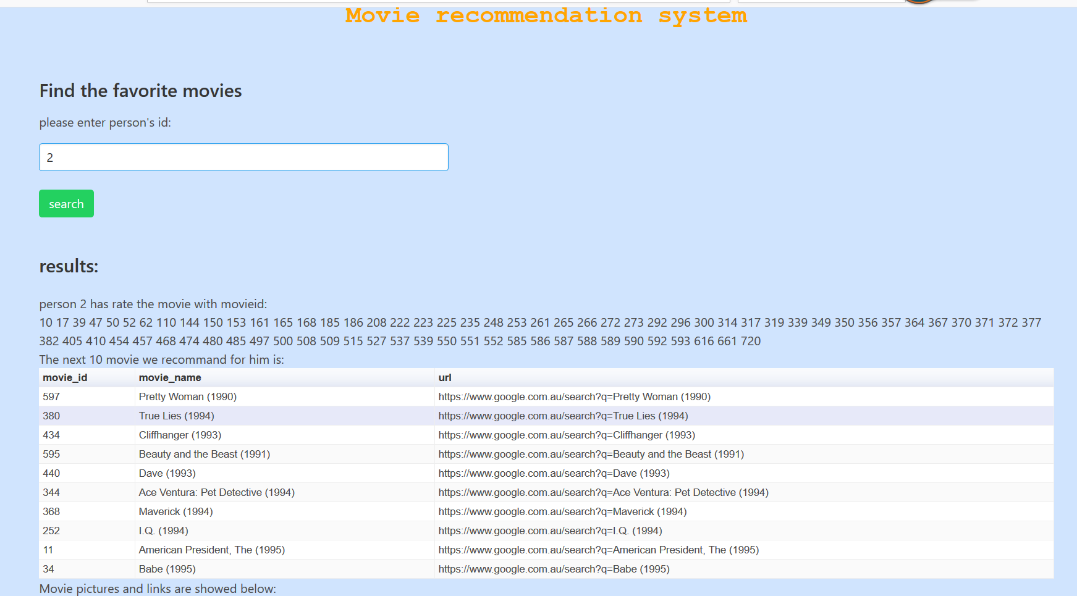

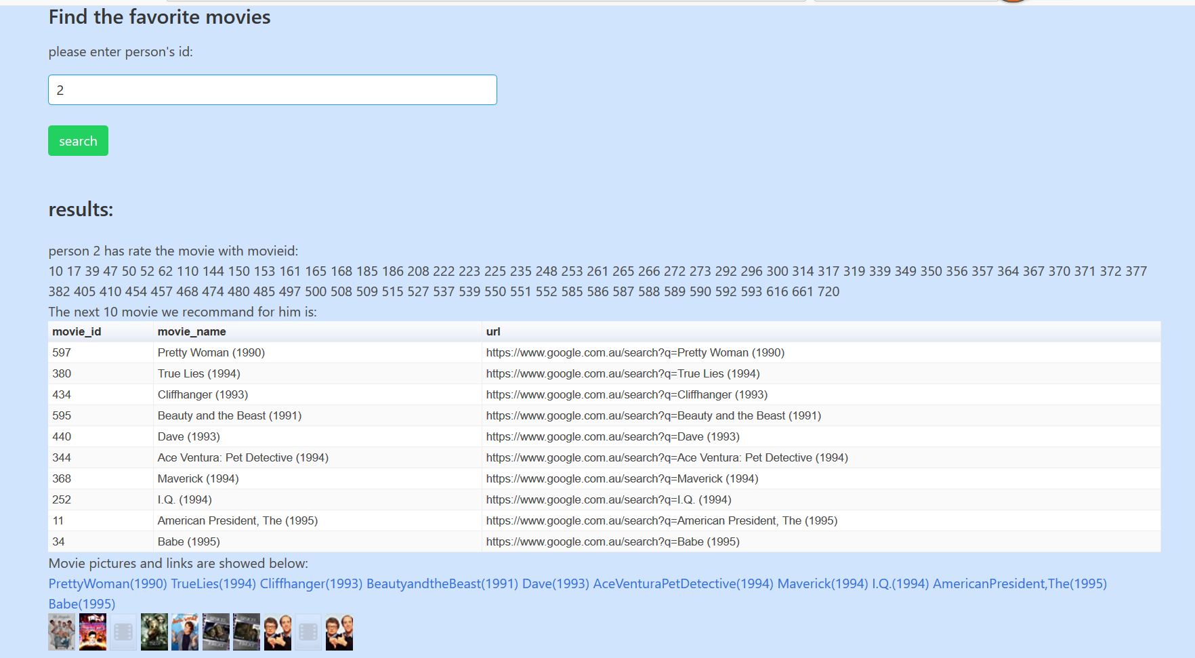

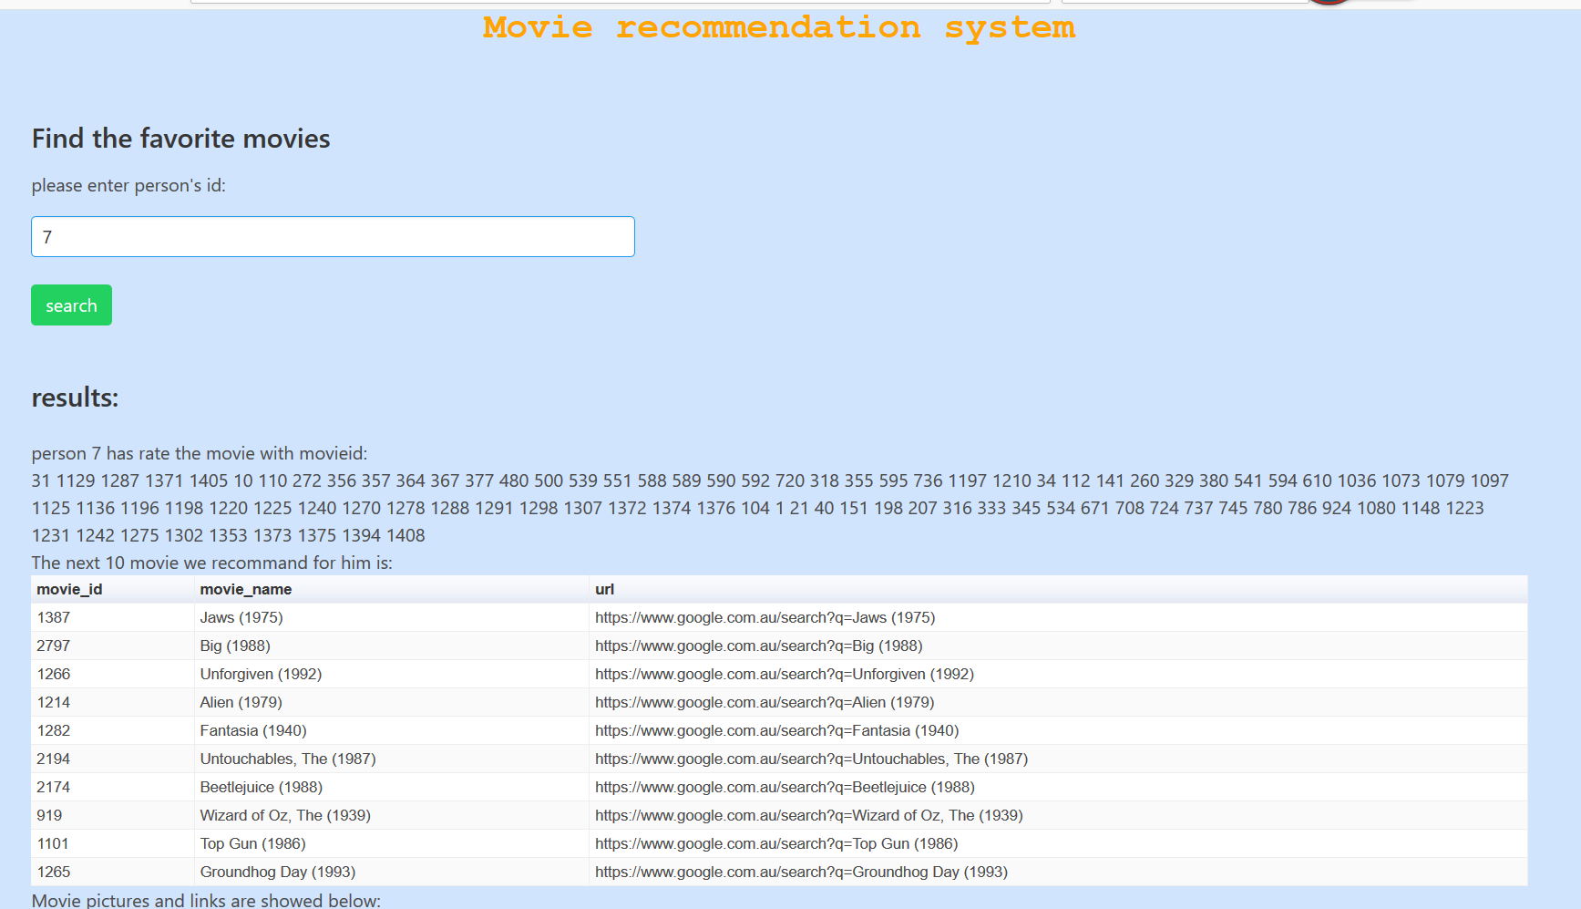

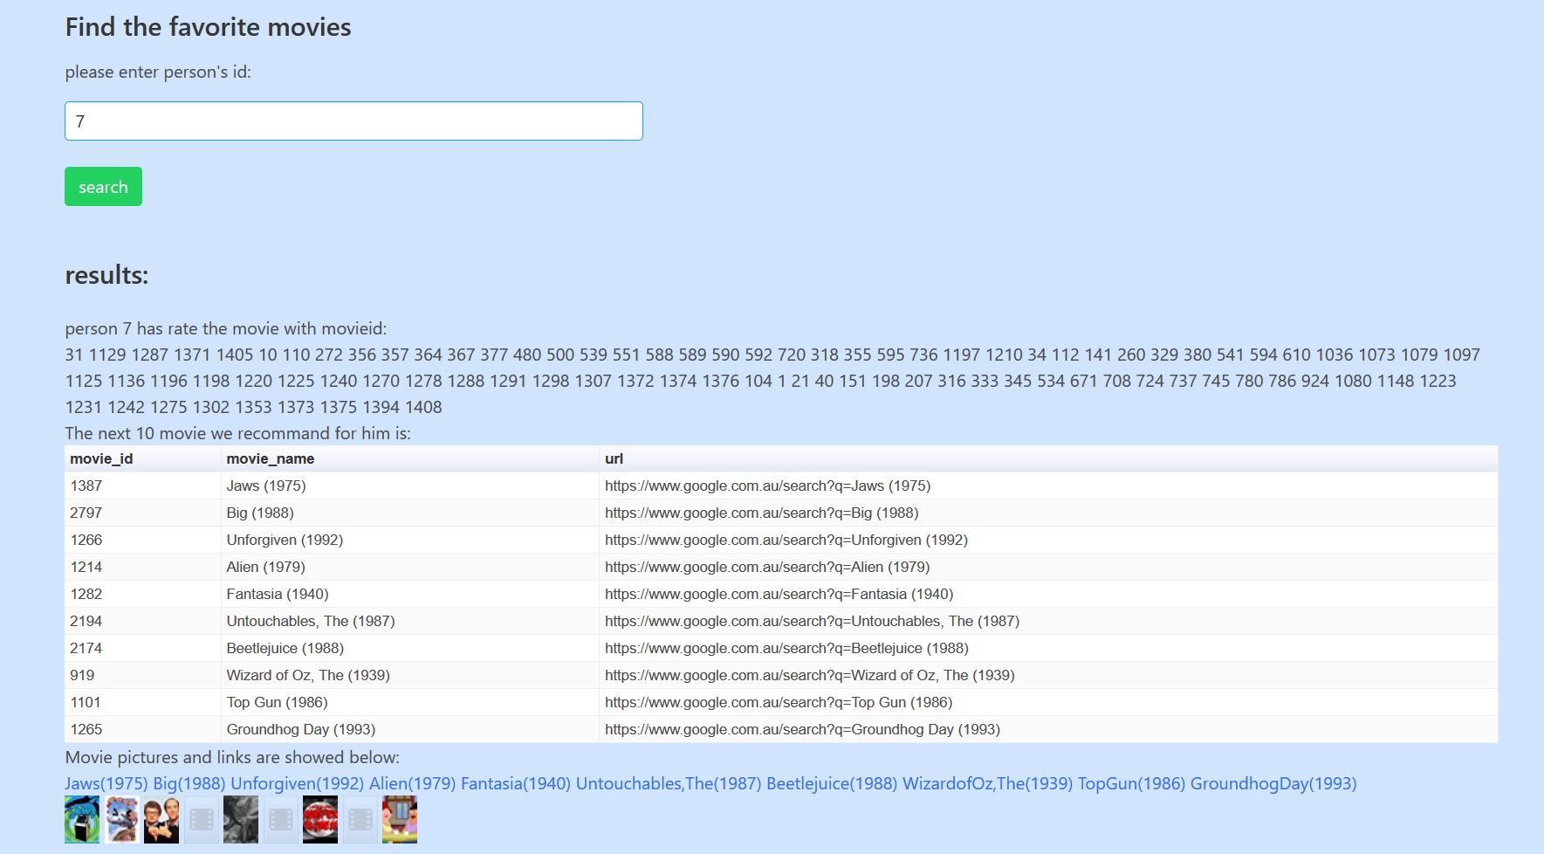

Related pages:

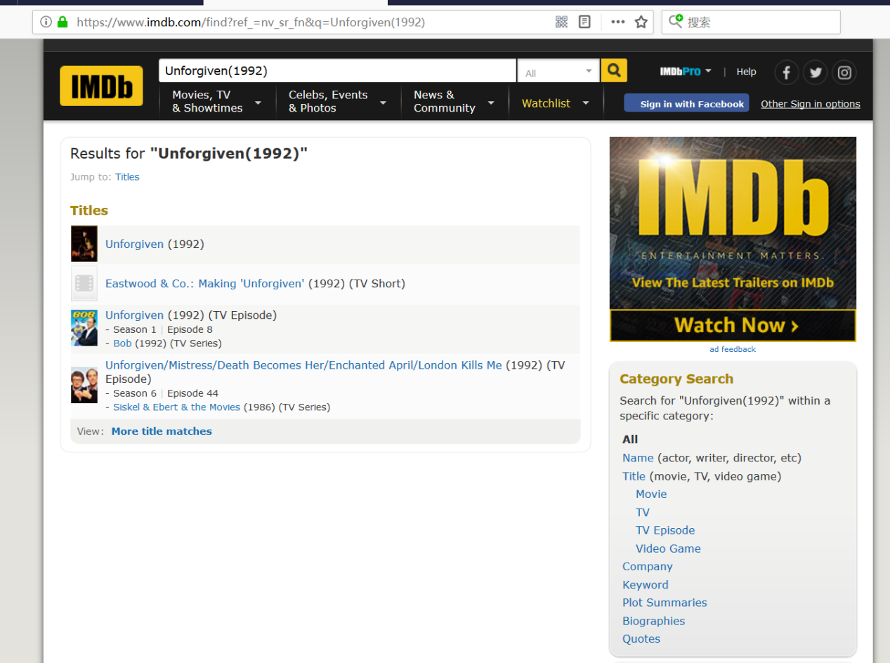

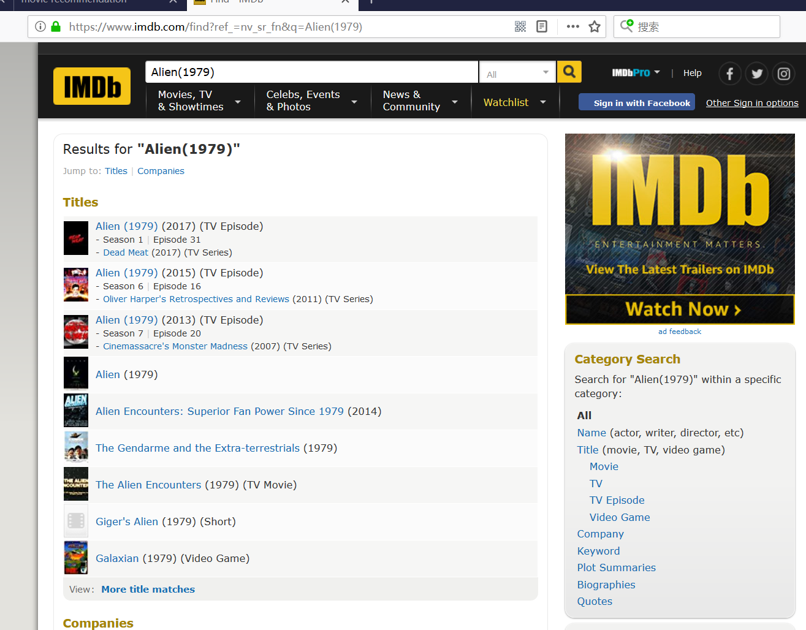

Flask module and some other modules are used in main.py.We use recommendation.py to calculate the results and transfer the results into json format.Then data of json format are sent to front end.These pictures which are related to movies are download from website ‘https://www.imdb.com/’ automatically.